Microsoft Intune + Windows Device Management – Solution Design Document
16/05/2025

Document Control 3
Content
Project Information 3
Responsibilities 3
Revision History 3
1. Executive Summary 4
2. Background & Scope 4
2.1 Client Context 4
2.2 Project Focus 4
2.3 Scope Boundaries 4
3. Design Principles 5
4. Existing Environment 5
4.1 On-Premises Infrastructure 5
4.2 Cloud Infrastructure (Planned) 5
5. Solution Design Overview 6
6. Architecture Diagram & Explanation 6
6. Tenant Onboarding Steps in Azure 7
7. Identity & Directory Integration 7
7.1 Entra ID (Azure AD) Prerequisites: 7
7.2 Directory Integration Details Table 8
9. User/Device Enrollment Flows 8
10. Security & Network Controls 9
11. Policy Matrix 9
11.1 Compliance Policies 9
11.2 Configuration Profiles 9
12. Security Baselines & Compliance Profiles 10
13. Licensing Considerations & Integration Points 10
14. Application Management 10
15. Monitoring & Reporting 11
16. Integration Considerations 11
17. Testing & Validation Plan 11
18. User Scenarios & Usage Stories 12
19. Technical Assumptions & Constraints 12

Document Control

Project Information
Project Name | Microsoft Intune – Windows Device Management
Program Manager | George Alex

Responsibilities
Authors | Role | Contact Details
Vipin Dubey | Solution Consultant | M: xxxxxxxx  E: Vipin.dubey@orro.group

Version | Date | Amendment | Author
1.1 |  | First Draft | Vipin Dubey
1.2 |  | Second Draft | Vipin Dubey
1.3 | 23/09/2025 | Added Entra Connect permission requirements | Olli Ojala
1.4 | 8/10/2025 | Added identified risk for AD exposure via Intune | Olli Ojala

Revision History

- Executive Summary
This document provides a comprehensive technical solution design for the implementation of Microsoft Intune to manage approximately 6–10 Windows laptops used by field engineers in a hybrid on-premises/cloud environment. The design integrates the NWR’s existing on-premises Active Directory, retains Duo MFA, and establishes a secure, scalable endpoint management solution suitable for operational technology environments. This solution addresses the unique operational context of shared devices, restricted internet access, and minimal IT resources.

2. Background & Scope

2.1 Client Context
Northwestern Roads is a road management company responsible for maintaining road infrastructure, sensors, and cameras. Their workforce includes field engineers who depend on shared laptops to perform diagnostics, maintenance, and system updates on field-deployed devices.

2.2 Project Focus
The project focuses exclusively on managing 6–10 Windows laptops through Microsoft Intune (Microsoft Endpoint Manager), integrating this solution with the client’s on-premises Active Directory environment while retaining Duo MFA as the multi-factor authentication provider. The devices are used in a shared model with minimal or no general internet access.

2.3 Scope Boundaries
- Only Windows laptops are in scope; no iOS, Android, or macOS devices are part of the design.
- Despite an existing Microsoft 365 E5 license, features such as Microsoft Defender for Endpoint, Sentinel, or Purview will not be implemented during this phase.
- Software packaging and deployment responsibilities will remain with the SICE team.
- Intune will be used to configure, secure, and manage devices; it will not handle software deployment unless explicitly requested in future phases.
- Devices will have limited internet access, restricted only to approved services.

3. Design Principles
This solution is guided by key principles to ensure technical and operational success:
- Simplicity: Leveraging out-of-the-box configurations where possible, avoiding unnecessary customization.
- Security: Enforcing core security measures including encryption, MFA, firewall, anti-malware, and access control.
- Scalability: Preparing for growth beyond the initial 6–10 devices without major redesign.
- Compliance Readiness: Building a foundation that aligns with potential compliance needs such as Essential 8 and IEC 62443 standards.
- Operational Alignment: Ensuring that device policies support shared-use workflows without interfering with field operations.

4. Existing Environment

4.1 On-Premises Infrastructure
NWR currently operates an on-premises Active Directory domain managing all user accounts and device authentication. Duo MFA is implemented for Windows login and VPN connections. Software deployment and troubleshooting are managed manually by the internal IT team.

4.2 Cloud Infrastructure (Planned)
A new Microsoft 365 tenant has been provisioned with an E5 license. Currently, no configuration has been applied for Azure AD Connect, Intune, Conditional Access policies, or any hybrid identity integration. This Azure tenant is used for NWR secure remote access project as well. RBAC will be used to prevent any unauthorised access to the deployed resources.

5. Solution Design Overview
The solution will establish hybrid identity by integrating on-premises Active Directory with Azure AD (Microsoft Entra ID) via Azure AD Connect (Entra Connect). Devices will be hybrid Azure AD joined for management across on-prem and cloud directories. Microsoft Intune will manage device compliance, configuration, and security, while Duo MFA remains the authentication provider for VPN and Windows logins.
In addition to integration, this design provides:
- Tenant onboarding procedures
- Azure/Entra ID prerequisites
- Policy configuration templates
- Security baselines
- Licensing clarifications
- Integration considerations

6. Architecture Diagram & Explanation
This diagram illustrates the flow of authentication, device management, policy application, and network filtering between the client’s on-premises infrastructure, Azure AD, Intune, Duo MFA, firewalls, and end-user devices.
A legend will define icons representing servers, cloud services, endpoints, and authentication paths. A disclaimer notes that assumptions are made due to no direct environment access at this stage.

6. Tenant Onboarding Steps in Azure
The following steps will be performed to onboard the Microsoft 365 tenant:
- Confirm global admin access to tenants
- Verify primary domain ownership (via DNS TXT record)
- Add custom domains (if applicable)
- Validate DNS records for Intune endpoints
- Set baseline security defaults (MFA for admin accounts, password policies as per NWR standard password management)
- Assign required Intune licenses to pilot users/devices
- Enable Microsoft Intune MDM authority
- Review conditional access baseline policies
- Validate admin roles and permissions
NWR specific tenant name and DNS record details

7. Identity & Directory Integration
Azure AD Connect will synchronize on-premises AD with Azure AD using password hash sync. Azure AD Connect will be configured for password hash synchronization to replicate user accounts and passwords from on-premises Active Directory to Azure AD. For the initial configuration of Entra Connect Orro requires a Domain Admin permission. These permissions can be revoked after the project completion. Entra Connect uses service account to connect on-premises AD to Entra ID. Detailed requirements for Entra Connect permissions are documented on the Ref 1. Hybrid Azure AD Join will allow devices to be recognized by both directories.
Implementing Intune management for on-premises laptops requires network connectivity between the cloud service and the on-premises Active Directory, which introduces potential exposure of the AD infrastructure to external threats. To minimize this risk, the solution will implement strict firewall rules limiting connectivity to only required ports and protocols, use least-privilege service accounts and implement continuous monitoring and logging of all cloud-to-on-prem traffic.
Duo MFA will continue as the authentication layer for remote services (VPN/Bastian Host and Share File). Compatibility testing will ensure no conflicts arise with hybrid join or Intune enrollment processes.

7.1 Entra ID (Azure AD) Prerequisites:
Prerequisite | Detail
Supported OS | Windows 10/11 Pro or Enterprise
DNS Resolution | Confirmed for *.microsoftonline.com, *.azure.com
Firewall Ports | Ports 443, 80 open outbound to Azure endpoints
TLS Requirements | TLS 1.2 minimum supported
Time Synchronization | AD servers synchronized within 5 minutes drift
Azure AD Connect will be configured for password hash sync. Hybrid Azure AD Join will be enabled for Windows devices. Existing GPOs will be reviewed for conflicts.

7.2 Directory Integration Details Table
Setting | Value/Config
Sync Scope | [Insert OU scope]
Hybrid Join Enabled | [Yes/No]
Password Sync | [Yes/No]
8. Device Management
Devices will be manually enrolled into Intune post-hybrid join configuration. Compliance policies enforced through Intune will include:
- Mandatory BitLocker encryption.
- Active Microsoft Defender Antivirus.
- Enabled Windows Firewall.
- Minimum password and PIN complexity.
Device Name | OU Path | Assigned Group | Notes
[Device1] | [Insert] | [Insert] | [Insert]
Configuration profiles include:
- Mandatory checks of S1 and R7 agent existence and operation
- Shared device mode
- Auto-lock & sign-out
- Removal of local admin
- VPN/Wi-Fi profiles (Use cases gathering of engineers for internet usage when on road need to be discussed)
Screenshot NWR: [We can Insert Intune profile screenshots later here]

9. User/Device Enrollment Flows
Devices will follow a hybrid join + Intune enrollment flow:
- Device joins on-premises Active Directory
- Azure AD Connect syncs device object to Azure AD
- GPO or manual method triggers automatic Intune enrollment
- Device appears in Intune admin center
- Compliance policies and configuration profiles are applied
- User logs in with domain credentials + Duo MFA (Duo not required when login to laptop)
- Intune validates compliance status
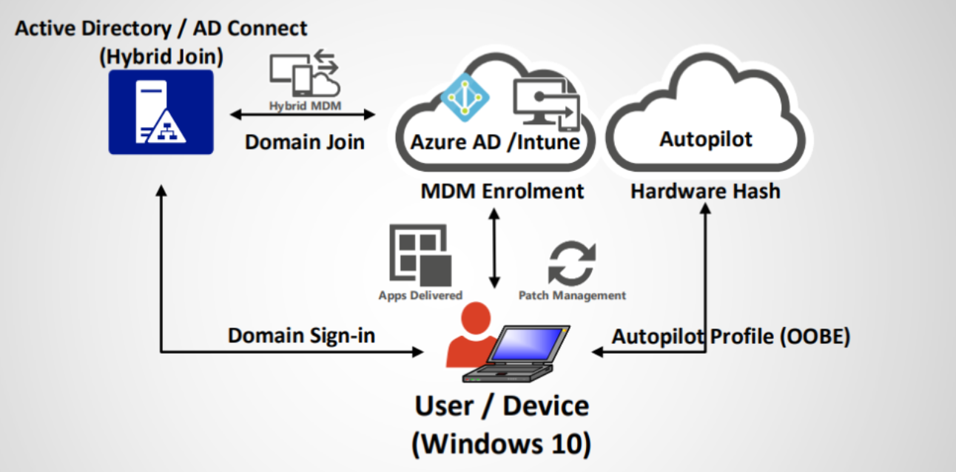

10. Security & Network Controls
Internet access is restricted to approved services. Authorized endpoints include Microsoft 365 services, client intranet resources, VPN gateways, and critical operational application servers.
Browser restrictions may be enforced via AppLocker or Intune policy to prevent unauthorized browsing.
Approved Domain/Service | Description
*.microsoft.com | Microsoft services
[Insert] | [Insert description]

11. Policy Matrix

11.1 Compliance Policies
Policy Name | Setting | Value
Encryption Policy | Require BitLocker | Enabled
Antivirus Policy | Require Defender AV | Enabled
Firewall Policy | Require Windows Firewall | Enabled
Password Policy | Min Length | 8 chars

Note: Password policy should align with SICE AD on prem policy (NWR Standard)

11.2 Configuration Profiles
Profile Name | Setting | Value
Shared Device Profile | Auto Sign-out | Enabled
Shared Device Profile | User Profile Cleanup | Enabled
Wi-Fi Profile | SSID | [Insert]

12. Security Baselines & Compliance Profiles
Microsoft Intune security baselines will be used as a starting point:
- Enforce Windows Defender AV
- Block removable storage
- Require secure boot
- Block legacy authentication protocols
- Disable SMB1 protocol
- Enable tamper protection
Customizations may be applied per operational requirements.

13. Licensing Considerations & Integration Points
NWR holds Microsoft 365 E5 licenses, which include:
- Microsoft Intune
- Azure AD Premium P1
- Conditional Access
- Defender for Office 365
Current scope does not implement Defender for Endpoint or Sentinel. However, licensing entitles client to enable these in future phases.
Integration points:
- Azure AD + Intune integration via tenant
- Azure AD Connect sync integration
- Duo MFA retained for authentication (no switch to Entra MFA)

14. Application Management
All software installation will be managed by NWR’s IT team. At this time, no operational applications will be packaged via Intune. Future consideration may include packaging Win32 apps or using Company Portal for self-service installs.
NWR client-specific apps:
Application Name | Source | Deployment Method
[Insert] | [Insert] | [Manual/Intune]

15. Monitoring & Reporting
Microsoft Endpoint Manager dashboards will monitor compliance, enrollment, and device health. Reports will be scheduled to provide insights on policy application, security status, and device inventory.
The integration with existing SOC and Sentinel SIEM is mandatory. Reporting needs to be added to the monthly delivered reports.
Reports to include:
- Device compliance status
- Enrollment status
- Policy application status
NWR can add screenshot/example report export.

16. Integration Considerations
- Validate Duo MFA compatibility with hybrid joins and Intune.
- Confirm no conflicts between existing GPO and Intune profiles.
- Assess bandwidth and latency at field locations.
- Ensure reliable access via jump host (RDP) for implementation without direct credential sharing.
- Validate Duo MFA integration with Intune and hybrid join.
- Confirm firewall ports open for Azure AD Connect & Intune.
- NWR: [Add NWR-specific network security notes]

17. Testing & Validation Plan
Test Step | Expected Result | Actual Result | Status
AD Connect Sync | Users synced successfully | [Insert] | [Insert]
Hybrid Join | Device joined Azure AD | [Insert] | [Insert]
(Screenshots and logs to be inserted post-validation)

18. User Scenarios & Usage Stories
Scenario 1:
Field engineer logs into shared laptop → authenticates with Duo MFA → connects to VPN → uses diagnostics → auto-logout triggers after inactivity.
Scenario 2:
IT admin uses Intune portal → remotely wipes lost laptop → revokes compliance.
(Insert additional scenarios as needed)

19. Technical Assumptions & Constraints
Assumption | Details
Windows 10/11 Pro | Required for hybrid join
Duo MFA remains | No transition to Azure MFA
Jump host required | RDP access for Entra ID Connect
Ports allowed | Firewall ports open for Azure AD/Intune (Ref 2.)
DNS allowlist | *.microsoft.com, *.azure.com approved
* Enabling ports and DNS allow lists through the firewall is required.

20. Glossary
Term | Definition
Intune | Microsoft Endpoint Manager platform
Azure AD Connect | Syncs on-prem AD to Azure AD
Hybrid Join | Device joined to on-prem + Azure AD
Duo MFA | Multi-factor authentication platform

21. References

Ref 1. Microsoft Entra Connect: Accounts and permissions - Microsoft Entra ID | Microsoft Learn

Ref 2. https://learn.microsoft.com/en-us/intune/intune-service/fundamentals/intune-endpoints?tabs=north-america




1300 900 000
hello@orro.group
orro.group

